Contents

Task 01 1

Code 1

Output 2

Task 02 2

Code 2

Output 3

Graph 3

Task 03 4

Code 4

Output 4

# Task 01

## Code

clc

clear all

close all

% A)

% graphical method

syms y

Q=20;

g=9.8;

Ac=3*y + y^2/2;

B=3+y;

graph_method=1 - ((Q^2)/(g*Ac^3))*B;

graph_method=solve (graph_method,y);

Ans_A=real(vpa(graph_method));

Ans_A=Ans_A(Ans_A>=0)

% B)

% using bisection

error=1;

del=0.25;

xl=0.5;

xu=2.5;

xr=(xl+xu)/2;

Ac=3*xl + xl^2/2;

B=3+xl;

fl=1 - ((Q^2)/(g*Ac^3))*B;

while(error>0)

Ac=3*xu + xu^2/2;

B=3+xu;

fu=1 - ((Q^2)/(g*Ac^3))*B;

Ac=3*xr + xr^2/2;

B=3+xr;

fr=1 - ((Q^2)/(g*Ac^3))*B;

xl=1.5;

Ac=3*xl + xl^2/2;

B=3+xl;

fl2=1 - ((Q^2)/(g*Ac^3))*B;

f=fl2*fl;

xr2=(xl+xu)/2;

error=abs((xr2-xu)/2)*100;

xu=xu-del;

end

bisection_root=xr2

% C)

% false position method

x0=0.5;

x1=2.5;

tol=0.01;

f=@(x) 1 - ((Q^2)/(g*(3*x + x^2/2)^3))*(3+x);

while (1)

x2=x1 - (f(x1)*(x1-x0)/(f(x1)-f(x0)));

c=f(x2);

abs_c=abs(c);

if abs_c<tol

break

end

if f(x0)*c<0

x1=x2;

else

x0=x2;

end

end

fals_pos_root=x2

## Output

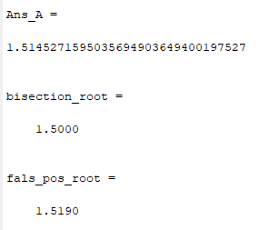

# Task 02

## Code

clc

clear all

t=linspace(0,2);

f=@(t) 9*exp(-t)*sin(2*pi*t)- 3.5;

y=[];

for i=1:length(t)

y=[y f(t(i))];

end

plot(t,y)

grid on

xlabel('time --->')

title('Signal at t values')

ylabel('y--->')

t1=fzero(f,[0,.2])

t2=fzero(f,[0.2,.8])

## Output

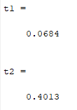

## Graph

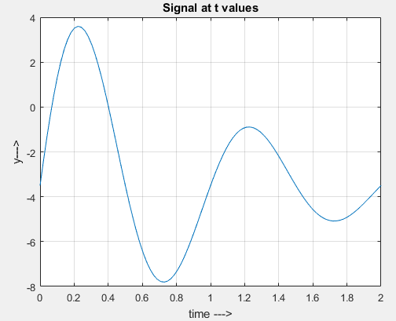

# Task 03

## Code

clc

clear all

close all

R=3;

V=30;

% false position method

h0=0;

h1=3;

f=@(h) pi*h^2*abs(3*R-h)/3 - V;

for i=1:3

h2=h1 - (f(h1)*(h1-h0)/(f(h1)-f(h0)));

c=f(h2);

abs_c=abs(c);

if f(h0)*c<0

h1=h2;

else

h0=h2;

end

end

disp(['bisection guess after three iteration ',num2str(h2)])

## Output

